  Object Oriented Programming Report  Sec(3) | Name: Mohammed Nairoukh  Student ID : 2410205  Instructor : Dr. Ola Surakhi

1.Introduction
- This application mimics a simple course registration system, enabling students to sign up for and drop classes, allowing instructors to keep track of registered students, and saving student and course information in a text file.
2. Design Choice
- Person class was created as an abstract base class that is inherited by the teacher and students.
Encapsulation ensures safe access and preserves data integrity by combining private members with public members (getter/setter).
DisplayInfo() became a virtual function due to polymorphism, allowing any subclass to alter its output.
Students, the instructor, and the course name are stored in a vector. To handle exceptions, we utilize try/catch with runtime_error and out_of_range.
In order to store data on disk permanently, file I/O is utilized offstream to save student and course information to text files.
3. Highlights in particular
- If the course is filled, Addstudent() raises an exception. By doing this, silent logic errors are prevented and reliability is increased.
Every class has distinct roles and responsibilities, and the instructor keeps track of the students' points.
To differentiate between regular and error output, the Cerr method is utilized for error massage.

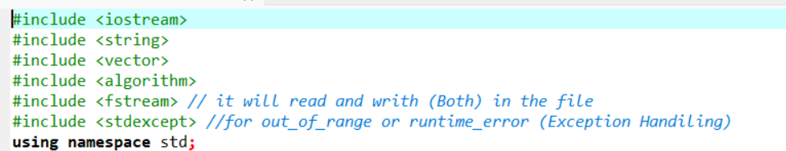

- Here we use the [vector(to declare the student and course info in a vector), algorithm ,fstream(for read and write in the file ), stdexcept (we use it for out_range,runtime_error functions )
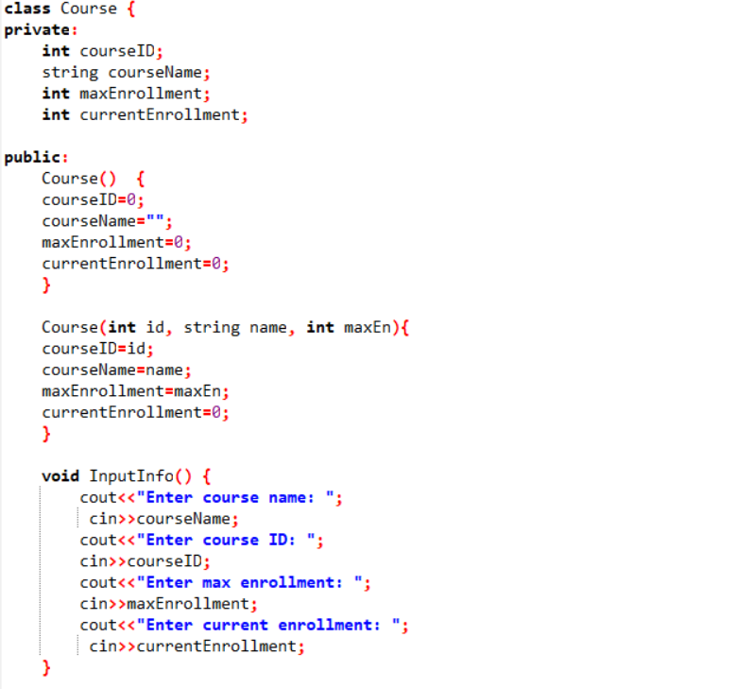

- First of all we start with create a Course class then we declare the course id and course name and max enrollment and current enrollment as private member because its sensitive informations then we put public and we create a default constructor then also we create a overloading constructor.
- Then we create a function (InputInfo) to let the user to insert his information.

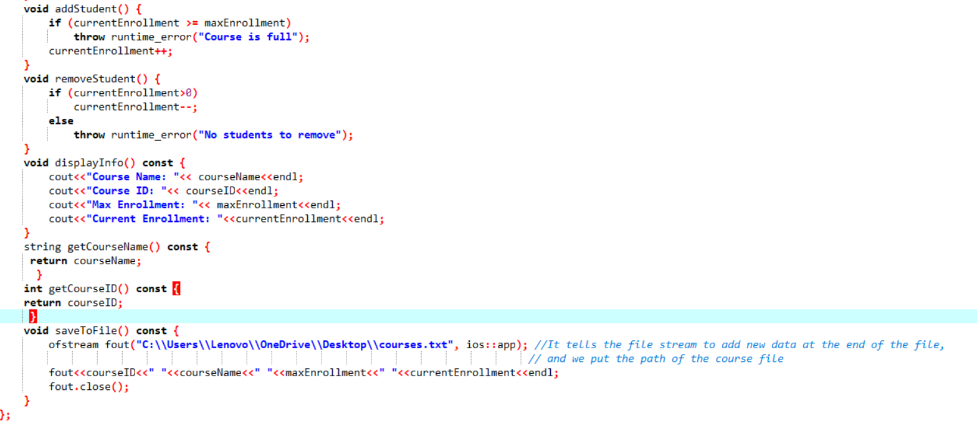

- Then we create a function (addStudent) to add the student in the course then we create a (removeStudent) function to remove student from the course
- Then we create a function (display()) to display the user information ( bay attention that the display function is the virtual function (abstract))
- We use the getter method because the course name and course id is private so we need the access
- Last thing in this class is we create a (SaveToFile) function here we use the ofstream but we need to check that we put the library which is #include <fstream> then after we put ofstream(“here we will put the file name or file path as I do “) and the ios::app we use it to add new element at the end of the file.
- Then we will print the data (course id,course name, max enrollment,current enrollment ) then we will close the file (fout.close()).
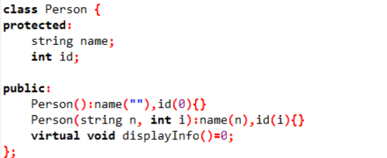
- Then we declare the Person class and we make it protected because we don’t want anyone see this sensitive information .
- Then we put public to show the public information .
- Then we use the overloaded constructor and because the id is integer so its equal zero and because name is string so its equal double quotation
- Then we declare the constructor catch sight of that the name of the constructor is the same name of class which is Person.
also we declare another variable to initialize object data when the object is created.
- And last of thing in this class is we use the virtual function (Abstract class ) and the Abstract class we cannot create an object for this class in the main function because its virtual so to solve this case we just make a overloaded function in the child class(Inherted class)
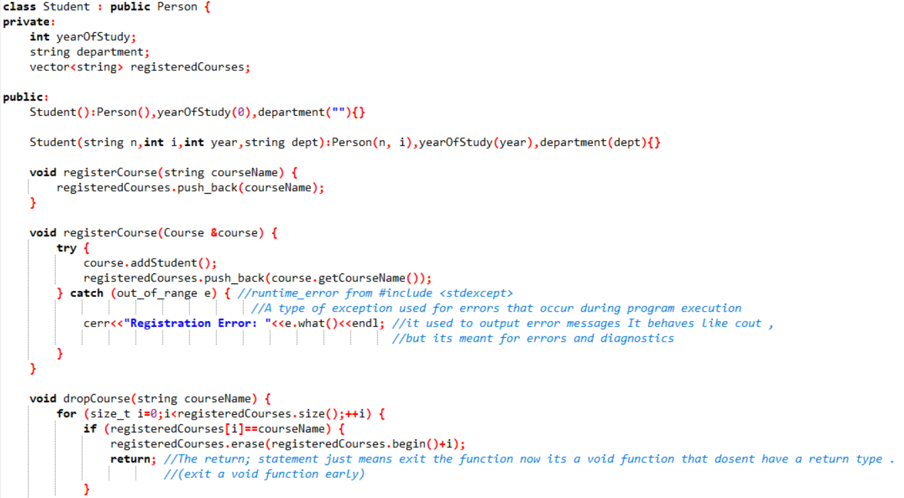
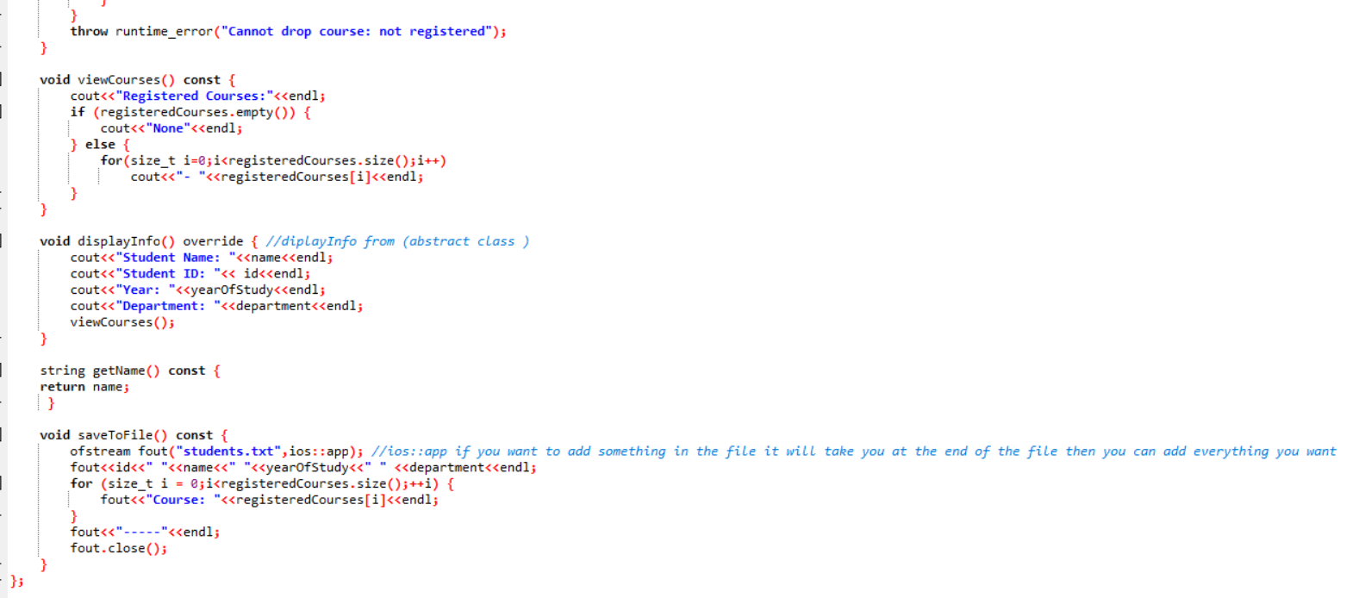

- Now we use the Inheritance (child class ) in another word derived from base class then we make the year of study , department ,and registered course is private because as I mention it it’s a sensitive information but when we declare the registered course we use the vector , vector like array it stores element, indexed access ,and fixed data type but when we want to use the vector there are some requirement we must to use it :
- We must to use the #include <vector> library
- The formula is vector <datatype> any name.
- Note : we can replace a class constructor and remove the datatype …example : vector<Person> v;
- Then we put the public :,and then we create a default overloaded constructor(be careful the constructor name must be the same name as the class name)
.…then we create constructor (be careful the constructor name must be the same name as the class name)
- Then we create a void function named registerCourse (bay attention that is the vector that we declared upward) inside the function we use the push_pack methode (in addition it gives you to add an element at the end of the vector )
- Then we create an overloading function and the condition is (passing by reference to access and modify the original course object directly). Now inside the function we use the exception handling (to avoid the exceptions errors) and we call it the try catch method here we don’t use the throw because this function is one catching the exception not throwing (trytry the code that might be fail ),(catch Handling the error),(throwsending an error/exception)
- Now inside the try we call the addStudent function from the Course class then we use the push_back to add an element at the last element in the vector . now in catch we use (out_of_range) also here we need to check if we put this library #include <stdexcept> because we use the out_of_range we can use the ( .what() ) it used to output error massage it behaves like cout .
- Now we create a dropCourse function to make sure that the student if he/she want to drop the course in semester period so simply we used the for loop to make sure that you are registered in the course that you want to drop it then we use the if statement to check that you are registered in inside the if statement we use the (erase) it will delete the last element at the end of the vector ,and the return here just mean exit the function now (it’s a void function)
- Then we put throw to take any except also here we use the runtime_error to tell that your not registered in this course.
- WE create a viewCourse function to display the student courses and (.empty()) it checks if the vector has no element .

- Now the display function which is virtual function but here is (overloaded) also to display the student information .
- We use the getter to get the name which is constant.
- And last thing in this class is a saveToFile function but not for course file now its for student file here also we use the ofstream to open the file and we specify the file inside the parameter which is the student file and a I mention that you can put the path of the file or you can put the file name . ios::app as I mention it before when you use it it will gives you to add anything at the end of the file (EOF) . then inside the for loop it will store the new data inside the file then we use fout.close() to close the file .

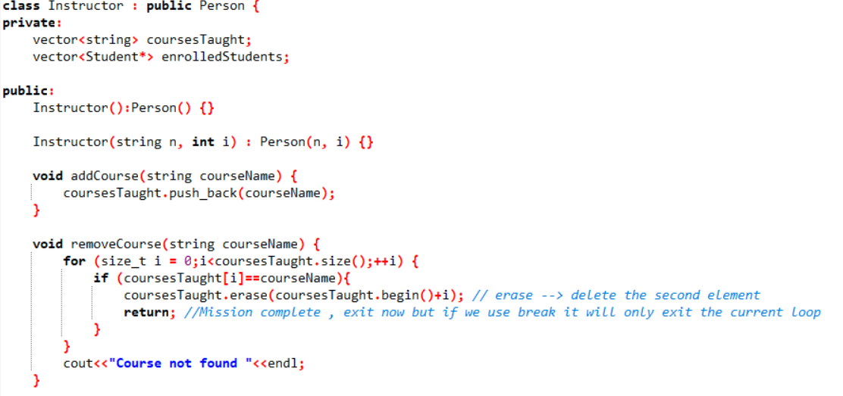

- Instructor class (inherited/derived from person class) ,we declare the coursetaught and enrolledstudent as a private member then we create a constructor .
- We create a void type function (addCourse) inside the function as I mention we add the push_pack method which you can add an element at the end of the vector .
- Then we create a void function (removeCourse()) inside the function we declare the size to make sure what the course taught you have been taken the we use the if statement inside the if statement we but the erase function it gives you to delete the last element at the end of the vector.
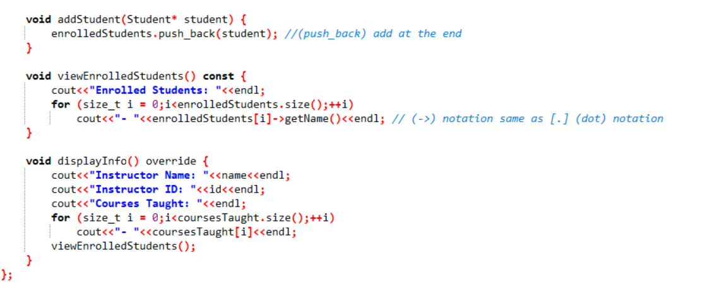

- The addStudent function we put inside the parameter pass by value then inside the function we use the push_back to add an element at the end of the vector.
- Then we create a viewEnrolledStudents function as a constant inside the function we use the for loop and we use inside the condition to take the size of enrolled student , [->] sign = [.] dot .
- Then the function displayInfo (virtual function) also override function to display the instructor information .

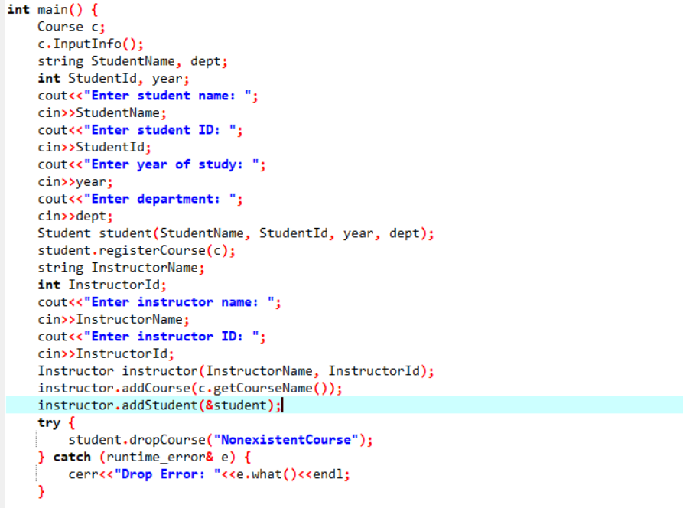

- In the main we create an object for the course class which is here (c) ,then we use the input notation so we just use c.InputInfo() to make the user to insert his information . then we declare the StudentName, dept, StudentId, year.
- Then we use the cin method to make the student to insert his information.
- Then we create an object for student class and send the values which is StudentName, StudentId, year, dept
- Then we use the dot notation [student.registerCourse(c);],then we declare InstructorName,and InstructorId
- And we use the cin methode to make the instructer to inser his information .
- Then we create an object fo instructor class which is instructor and inside the parameter we will send the instructor name and instructor id which is will be insert from the instructor .
- And here instructor.addCourse(c.getCourseName()); this line retrieves the course name from the course object and add it to the instructors list of taught course
- And here instructor.addStudent(&student); the instructor now has a reference to this student as one of their enrolled student
- Then we use the exception handling to make sure that the student if he/she dosent have a courses to drop it ,then we use runtime_error& first we will make sure that we but this library #include <stdexcept> then we can use it and we can use the .what() to display the error massage .
- Then we put c.saveToFile() to insert the course information to write the data inside the course file
- Last thing we put c.displayInfo();|| student.displayInfo();|| instructor.displayInfo(); to display the student and instructor and course information .
4.Conclusion
- We employ exception handling because the system adheres to important oop principles, supports user input through cin, and handles logic errors.

